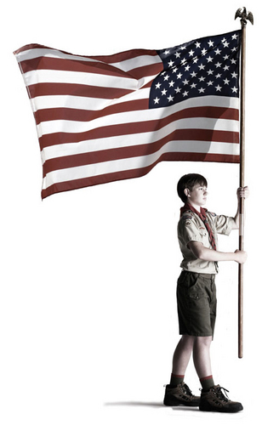

We enjoy freedom in our country like no other   
nation on this planet. Let's recognize those who have   
sacrificed much to have that great blessing and   
**line the streets of our neighborhood with flags!**   
What better way to show love for this country   
and those who have served to preserve it.

A subscription is $40* for these 8 dates:

**Feb 20 May 29 June 14 July 4   
 July 24 Sept 4 Sept 11 Nov 11**

***T o s i g n u p o n l i n e , v i s i t***

***http:// yourwebsite.com/flags/***

*\* If you'd like more than one flag displayed, add $10 for each additional flag  
...and thank you for supporting our 7th Annual Boy Scout Flag Service!*

**FLY A FLAG FOR FREEDOM**



We enjoy freedom in our country like no other   
nation on this planet. Let's recognize those who have   
sacrificed much to have that great blessing and   
**line the streets of our neighborhood with flags!**   
What better way to show love for this country   
and those who have served to preserve it.

A subscription is $40* for these 8 dates:

**Feb 20 May 29 June 14 July 4   
 July 24 Sept 4 Sept 11 Nov 11**

***T o s i g n u p o n l i n e , v i s i t***

***http://yourwebsite.com/flags/***

*\* If you'd like more than one flag displayed, add $10 for each additional flag  
...and thank you for supporting our 7th Annual Boy Scout Flag Service!*

**FLY A FLAG FOR FREEDOM**