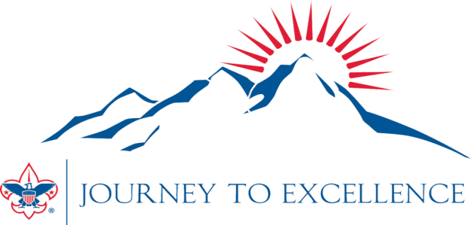
Troop Goals for 2014

 | Bronze | Silver | Gold
Advancement | 7 | 8 | 9
Trained Leaders | SM + ASM +  3 Committee | Bronze  + Leader-specific | Silver  + Comte Trained  + 1 Wood Badge
Short-term Camps | 4 | 7 | 9
Long-term Camps | JUST GO | 60%  (11 boys) | 70%  (13 boys)
Patrol Method | 4 | 6  + Annl Plan | 10  + Annl Plan  + 1 NYLT
Service Projects | 4 | 5 | 6
Courts of Honor | 2 | 3 | 4
Fitness Level | Low | Med | High

